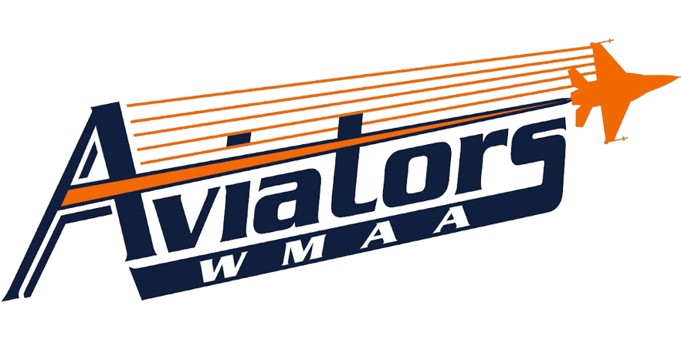
Strength Training

Mr. Wiggins

Course Description
The emphasis in this course is on muscular strength, endurance, flexibility, and safety. The core lifts in this course include parallel squats, power cleans, bench press, and incline press. Weight room safety, warm-up/cool down procedures, lifting technique and safety for all lifts, major muscle identification, and individual goal setting are all important components in this course. In addition, students will monitor and improve their fitness levels by participating in the Fitnessgram assessments throughout the semester.

Dressing for Class
Students are required to wear tennis shoes, athletic pants/shorts, and a t-shirt every day to class. Tennis shoes must be properly tied at all times. Athletic shorts must hang past mid-thigh, but may not be longer than mid-calf. Shirts must have sleeves. No yoga pants or tight fitting pants or shorts will be allowed. Not dressing for class will result in a loss of 5 out of 10 daily participation points, as long as the student still participates. If the student is dressed in a way that inhibits them from participating, they will lose all 10 daily points.

Tardies & Attendance
Research shows that student punctuality and attendance directly impacts achievement. It is expected that students will be in class and ready to begin on time. Tardies will result in a lose of 3 points on the student’s daily grade, we are confident that you can meet our expectations. Together, we will make WMAA a place where all students feel safe, feel connected and achieve. Unexcused absences will result in a 0; it is imperative for absences to be cleared by the office.

Grades
Students will earn a final grade each semester based on mastery of the course objectives. The cumulative
semester course work will comprise 20% of the final semester grade, and assessment and projects will comprise
60% of the final semester grade. A cumulative semester exam will comprise 20% of the final semester grade.
The final semester grade will be used in determining a student’s grade point average (GPA). Students’ semester
grade in physical education will be based on 3 components: daily grade, PE Crowning Project, and six
article reviews.

West Michigan Aviation Academy Grading Scale
Letter Grade | Percentage | Grade Point
A | 95-100% | 4.0
A- | 90-94% | 3.7
B+ | 87-89% | 3.3
B | 83-86% | 3.0
B- | 80-82% | 2.7
C+ | 77-79% | 2.3
C | 73-76% | 2.0
C- | 70-72% | 1.7
F | 0-69% | 0.0
INC | Incomplete Coursework | N/A

Coursework
WMAA will provide additional opportunities for students to show mastery of standards. Communication will occur frequently between teachers, students, and their parent/guardian concerning missing work. It is the student’s responsibility to meet with the teacher to determine the action plan.
If coursework is not turned in on time, a zero will be recorded in the grade book until the work is submitted.
This zero will be accompanied in the grade book with a “missing” marker so that the reason for the zero is evident.
If the allowable time period to make up the work has passed, the zero will become a permanent grade.

Character
Additionally, students will be evaluated on their character choices for each course. The character evaluation will reflect student mastery of WMAA’s critical character expectations: be respectful, be responsible, and do your personal best.

3- Exceeds Expectations 2- Meets Expectations 1- Currently Not Meeting Expectations

Gradebook – Available Online
WMAA grades will be available online through PowerSchool by visiting the following link: http://ps.westmichiganaviation.org/public/

