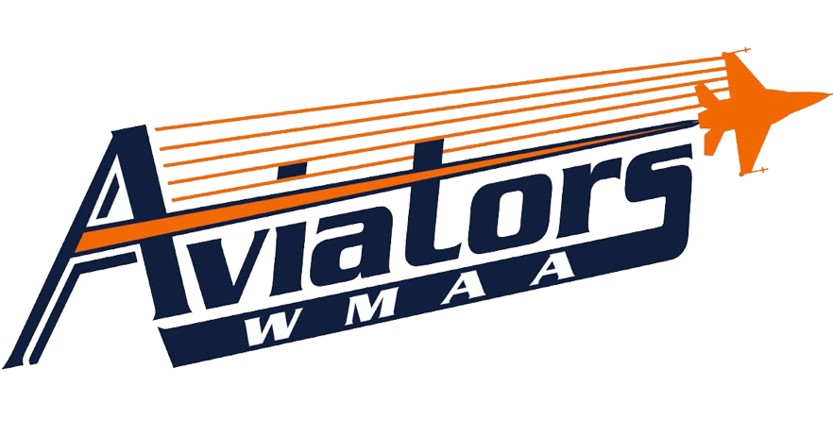
Physical Education
Mr. Wiggins

Course Description
The goal of the Physical Education class is to focus on the importance of maintaining good health in order to be successful in the field of aviation. The class will emphasize the impact that social, emotional, and mental health has on an individual’s physical health, thus affecting the student’s performance in the classroom and within their work environment. The physical education class will give WMAA students a chance to learn and practice skills in a variety of activities, while learning the importance of physical activity on their personal health and well being. Throughout the semester, WMAA students will learn how to record and track their fitness progress, by using the results of their fitness tests, which will occur three times per year. This integral part of the Physical Education class will emphasize the importance of being accountable for one’s own health and being able to relate good health to positive performance in the classroom and in the workplace.

Course Objectives
By the end of this course, WMAA students will be able to:
- Meet criterion-referenced age- and gender-specific, health-related fitness standards for cardiorespiratory, muscular strength and endurance, flexibility, and body composition
- Self-assess health-related fitness status for the purpose of developing individual goals and improving on previous scores.
- Use training principles when participating in physical activities
- Analyze the physiological indicators associated with moderate to vigorous physical activity to monitor and/or adjust participation/effort
- Demonstrate responsibility for achieving personal fitness goals.
- Participate in activities in a variety of settings (e.g., school, home, workplace, and community) in order to meet fitness needs.
- Identify and exhibit key behaviors, which exemplify each of the following personal/social character traits: responsibility, best effort, cooperation, compassion, cooperative competition, initiative, and leadership.
- Make a commitment to include physical activity as an important part of a healthy lifestyle.
- Exhibit and indicate enjoyment for aesthetic and creative aspects of skilled performance.

Dressing for Physical Education
Students are required to wear tennis shoes, athletic pants/shorts, and a t-shirt tucked in every day to class. Tennis shoes must be properly tied at all times. Athletic shorts must hang past mid-thigh, but may not be longer than mid-calf. Shirts must have sleeves. No yoga pants or tight fitting pants or shorts will be allowed. Not dressing for class will result in a loss of 5 out of 10 daily participation points, as long as the student still participates. If the student in dressed in a way that inhibits them from participating, they will lose all 10 daily points.

Tardies & Grades
Research shows that student punctuality and attendance directly impacts achievement. It is expected that students will be in class and ready to begin on time. We are confident that you can meet our expectations. Together, we will make WMAA a place where all students feel safe, feel connected and achieve. If a student is tardy walking in the gym or tardy getting in their squads (they have 4 minutes to change), they will lose 3 points from their daily participation. Unexcused absences will result in a 0; it is imperative for absences to be cleared by the office.

Grades
Students will earn a final grade each semester based on mastery of the course objectives. The cumulative semester course work will comprise 85% of the final semester grade, and assessment and projects will comprise 15% of the final semester grade. A cumulative semester physical exam will comprise 20% of the final semester grade. The final semester grade will be used in determining a student’s grade point average (GPA).

West Michigan Aviation Academy Grading Scale
Letter Grade | Percentage | Grade Point
A | 95-100% | 4.0
A- | 90-94% | 3.7
B+ | 87-89% | 3.3
B | 83-86% | 3.0
B- | 80-82% | 2.7
C+ | 77-79% | 2.3
C | 73-76% | 2.0
C- | 70-72% | 1.7
F | 0-69% | 0.0
INC | Incomplete Coursework | N/A

Coursework
WMAA will provide additional opportunities for students to show mastery of standards. Communication will occur frequently between teachers, students, and their parent/guardian concerning missing work. It is the student’s responsibility to meet with the teacher to determine the action plan.
If coursework is not turned in on time, a zero will be recorded in the grade book until the work is submitted. This zero will be accompanied in the grade book with a “missing” marker so that the reason for the zero is evident. If the allowable time period to make up the work has passed, the zero will become a permanent grade.

Character
Additionally, students will be evaluated on their character choices for each course. The character evaluation will reflect student mastery of WMAA’s critical character expectations: be respectful, be responsible and do your personal best.
3 – Exceeding Expectations
2 – Meeting Expectations
1 – Currently Not Meeting Expectations

Gradebook – Available Online
Powerschool: http://ps.westmichiganaviation.org/public/

