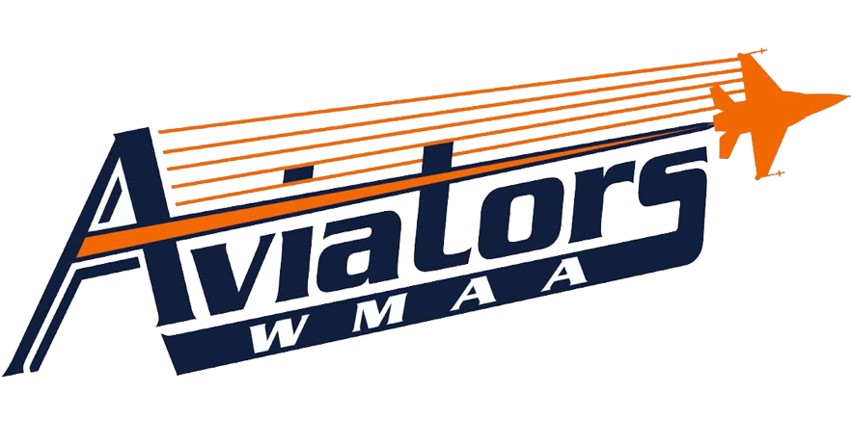
Lifetime Sports

Mr. Wiggins

Course Description
Lifetime Sports class is to focus on the importance of maintaining good health through team’s sports. The class will emphasize the psychomotor domain of being active, the cognitive domain of understanding the games, and affective domain of being a positive individual, thus affecting the student’s performance in the classroom and within their work environment. The class will give WMAA students a chance to learn and practice skills in a variety of activities such as volleyball, ultimate frisbee, team handball, speedball, eclipse ball, soccer, badminton, etc. WMAA students will learn how to record and track their fitness progress by using the results of their fitness tests, which will occur twice a year as well as using heart rate monitors during class activity. This integral part of the Lifetime Sports class will emphasize the importance of being accountable for one’s own health and being able to relate good health to positive performance in the classroom and in the workplace.

Dressing for Class
Students are required to wear tennis shoes, athletic pants/shorts, and a t-shirt every day to class. Tennis shoes must be properly tied at all times. Athletic shorts must hang past mid-thigh, but may not be longer than mid-calf. Shirts must have sleeves. No yoga pants or tight-fitting pants or shorts will be allowed. Not dressing for class will result in an automatic 5 out of 10 daily participation points, as long as the student still participates. If the student is dressed in a way that inhibits them from participating, they will lose all 10 daily points.

Tardies & Attendance
Physical Education is a participation class; therefore, being involved in the activity and good attendance are necessary.
Promptness to class indicates good work habits and cooperation. Students should be completely dressed in their P.E. uniform and sitting at their assigned spot when the instructor arrives. Absolutely no horseplay! If a student is not in roll call order, he/she will be marked absent or tardy.
Just being on the P.E. field does not constitute that a student is present in class. Students will receive one exempt unexcused absence but each one after that will result in a ZERO. Any excused absence will be exempt from the final grade.

Grades
Students will earn a final grade each semester based on mastery of the course objectives. The cumulative
semester course work will comprise 20% of the final semester grade, and assessment and projects will comprise
60% of the final semester grade. A cumulative semester exam will comprise 20% of the final semester grade.
The final semester grade will be used in determining a student’s grade point average (GPA). Students’ semester
grade in physical education will be based on 3 domains: Psychomotor (are they moving) Cognitive (do they understand) and Affective (how is their behavior)

West Michigan Aviation Academy Grading Scale
Letter Grade | Percentage | Grade Point
A | 95-100% | 4.0
A- | 90-94% | 3.7
B+ | 87-89% | 3.3
B | 83-86% | 3.0
B- | 80-82% | 2.7
C+ | 77-79% | 2.3
C | 73-76% | 2.0
C- | 70-72% | 1.7
F | 0-69% | 0.0
INC | Incomplete Coursework | N/A

Coursework
WMAA will provide additional opportunities for students to show mastery of standards. Communication will occur frequently between teachers, students, and their parent/guardian concerning missing work. It is the student’s responsibility to meet with the teacher to determine the action plan.
If coursework is not turned in on time, a zero will be recorded in the grade book until the work is submitted.
This zero will be accompanied in the grade book with a “missing” marker so that the reason for the zero is evident.
If the allowable time period to make up the work has passed, the zero will become a permanent grade.

Character
Additionally, students will be evaluated on their character choices for each course. The character evaluation will reflect student mastery of WMAA’s critical character expectations: be respectful, be responsible, and do your personal best.

3- Exceeds Expectations 2- Meets Expectations 1- Currently Not

Gradebook – Available Online
WMAA grades will be available online through PowerSchool by visiting the following link: http://ps.westmichiganaviation.org/public/

